**/** Example 1 : Thread in java */**

**import java.lang.Thread;**

**class A extends Thread**

**{**

**public void run()**

**{**

**for(int i = 0;i<=10;i++)**

**System.out.println("i = "+i);**

**}**

**}**

**class B extends Thread**

**{**

**public void run()**

**{**

**for(int j = 0 ;j<=20;j++)**

**System.out.println("j = "+j);**

**}**

**}**

**class C extends Thread**

**{**

**public void run(){**

**for (int k =0 ; k<=30;k++)**

**System.out.println("k = "+k);**

**}**

**}**

**class ThreadEg**

**{**

**public static void main(String[] args) {**

**A a = new A();**

**B b = new B();**

**C c = new C();**

**a.start();**

**b.start();**

**c.start();**

**}**

**}**

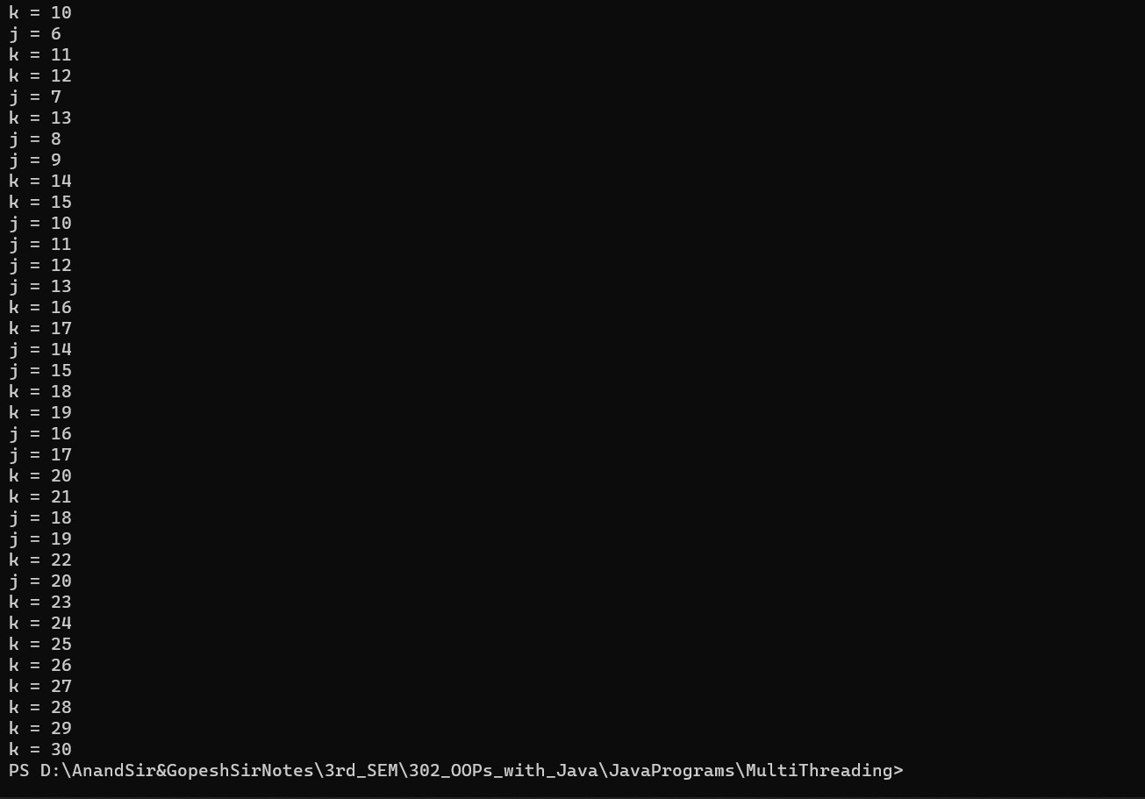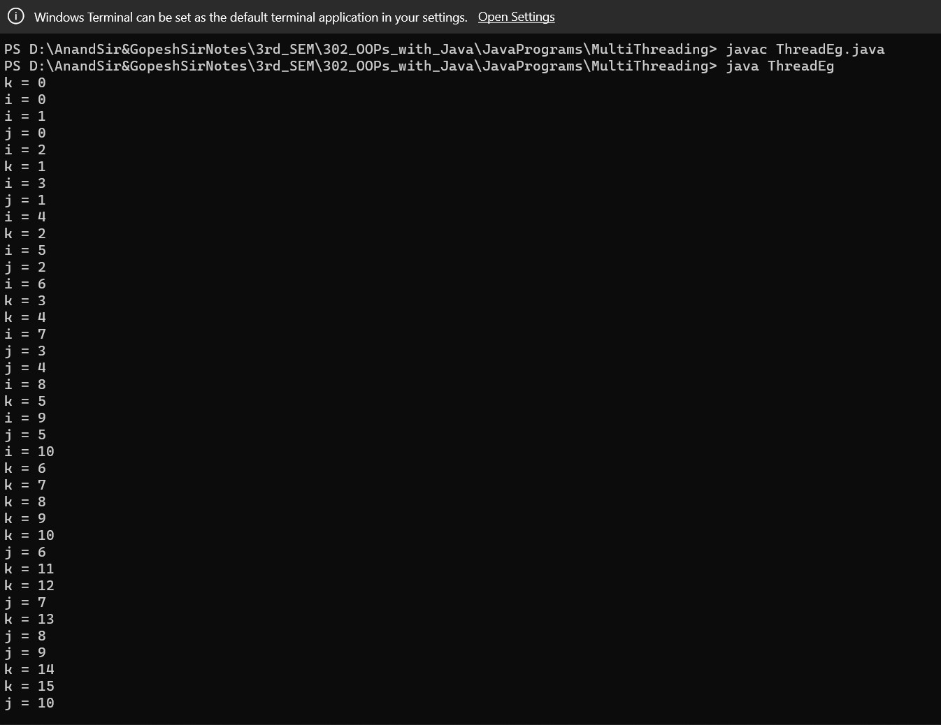**Output:**